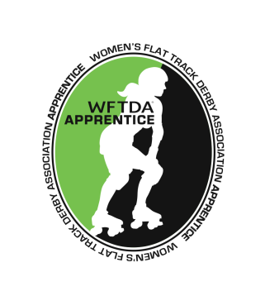
FOR IMMEDIATE RELEASE
2014-05-16

Dock City Rollers Accepted as Women’s Flat Track Derby Association Apprentice

Gothenburg, Sweden — The Women’s Flat Track Derby Association (WFTDA) is proud to announce today that Dock City Rollers has been accepted as an “Apprentice” affiliate of the WFTDA, the governing body for women's amateur flat track roller derby.

As an Apprentice affiliate of the WFTDA, Dock City Rollers joins the ranks of more than 300 all-female, skater-owned-and-operated leagues worldwide that have united to lead the growing sport of women's flat track roller derby.

WFTDA apprentice leagues are matched with veteran member leagues who guide them in the processes and requirements necessary to become a full member of the Association. WFTDA Apprentice leagues are considered “pre-members” of the WFTDA and have access to many of the resources and benefits of full WFTDA membership.

Dock City Rollers is currently preparing for the Swedish Championship which will take place in Borås, Sweden, 5th and 6th July. They are determined to defend and hopefully improve their third place ranking from last year’s Championship.

###

About the WFTDA

The Women’s Flat Track Derby Association is the governing body for women’s flat-track roller derby, and a membership organization for the leagues to collaborate and network. The organization created and maintained the first standardized ruleset for the flat-track game, now in its fourth edition. The WFTDA also serves as the sanctioning body for games, hosts tournaments, sets safety standards and provides insurance to athletes and leagues. There are currently 243 WFTDA member leagues and more than 101 apprentice leagues worldwide.

About Dock City Rollers
Dock City Rollers is a Roller Derby league right in the heart of Sweden – Gothenburg. The league was founded in December 2012 and consists of a group of passionate, dedicated people who all share the love for the greatest sport in the world: Roller Derby.

# # #
Contact:
Karin Edenholm Juliana Gonzales
President, DCR Executive Director, Women’s Flat Track Derby Association
(512) 587-1859
board@dockcityrollers.se Juliana@wftda.com

